Backup & Restore BW Domains

# Backup

Command to backup a domain (DomainD1_Dev) is given below:

./bwadmin backup -s /home/tibco/Domain_backups/Aug252016/backup_Aug252016.cmd domain DomainD1_Dev

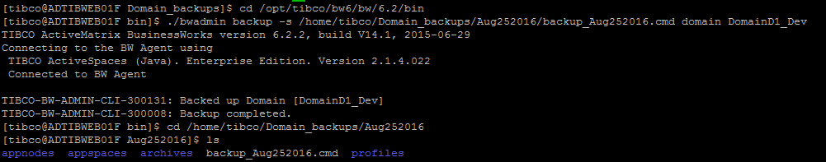

# Restore

Command to restore a domain (DomainD1_Dev) is given below:

./bwadmin -f /home/tibco/Domain_backups/Aug252016DEV/backup_Aug252016.cmd

